QA ASSIGNMENT: MASTER TEST COMPILATION

[BUG-01] Authentication Failure / Locked-Out Profile Restriction
Environment | Any modern browser with stable internet connectivity
Severity | Medium
Priority | Low
Status | New / Open
Description:
When attempting authentication with the profile 'locked_out_user', the application actively prevents session access and drops the user into an error containment state instead of routing to the core workspace dashboard.
Steps to Reproduce:
1. Navigate to the application web endpoint deployment URL: 'https://www.saucedemo.com/'
2. Populate the Username field with the identity string: 'locked_out_user'
3. Populate the Password field with the credential token: 'secret_sauce'
4. Trigger the form submission by clicking the 'Login' action button element.
Execution Results:
Expected: Successful authentication route and landing on 'https://www.saucedemo.com/inventory.html' populated with the unique inventory product assortment views.
Actual: Authentication fails; a system error banner is injected into the UI explicitly notifying the user that they have been locked out.
Attachment Field / Snapshots:
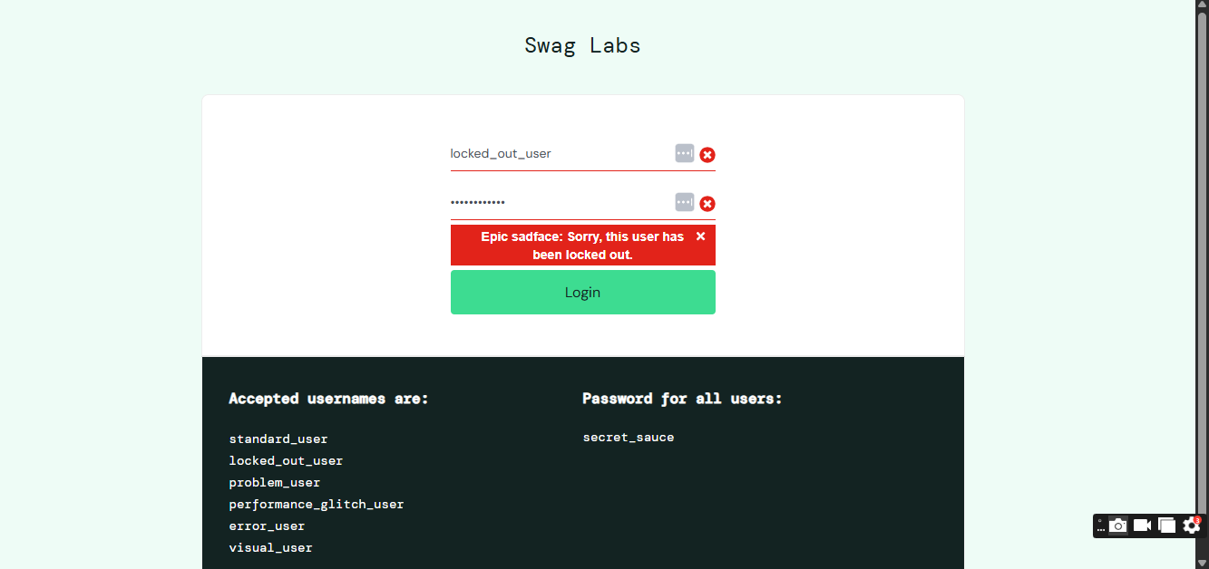
[BUG-02] All Products Display the Same Image (problem_user)
Environment | Any modern browser with stable internet connectivity
Severity | High
Priority | Medium
Status | New / Open
Description:
When logging into the application using the problem_user account, the product catalog fails to load the correct images for individual items. Instead, every single product displays the exact same image.
Steps to Reproduce:
1. Navigate to the application web endpoint deployment URL: 'https://www.saucedemo.com/'
2. Populate the Username field with the identity string: 'problem_user'
3. Populate the Password field with the credential token: 'secret_sauce'
4. Trigger the form submission by clicking the 'Login' action button element.
Execution Results:
Expected: The inventory page (/inventory.html) should load normally, showing a unique, matching image for each individual product.
Actual: The page loads, but every product displays the exact same repeated image file, disrupting layout consistency.
Attachment Field / Snapshots:
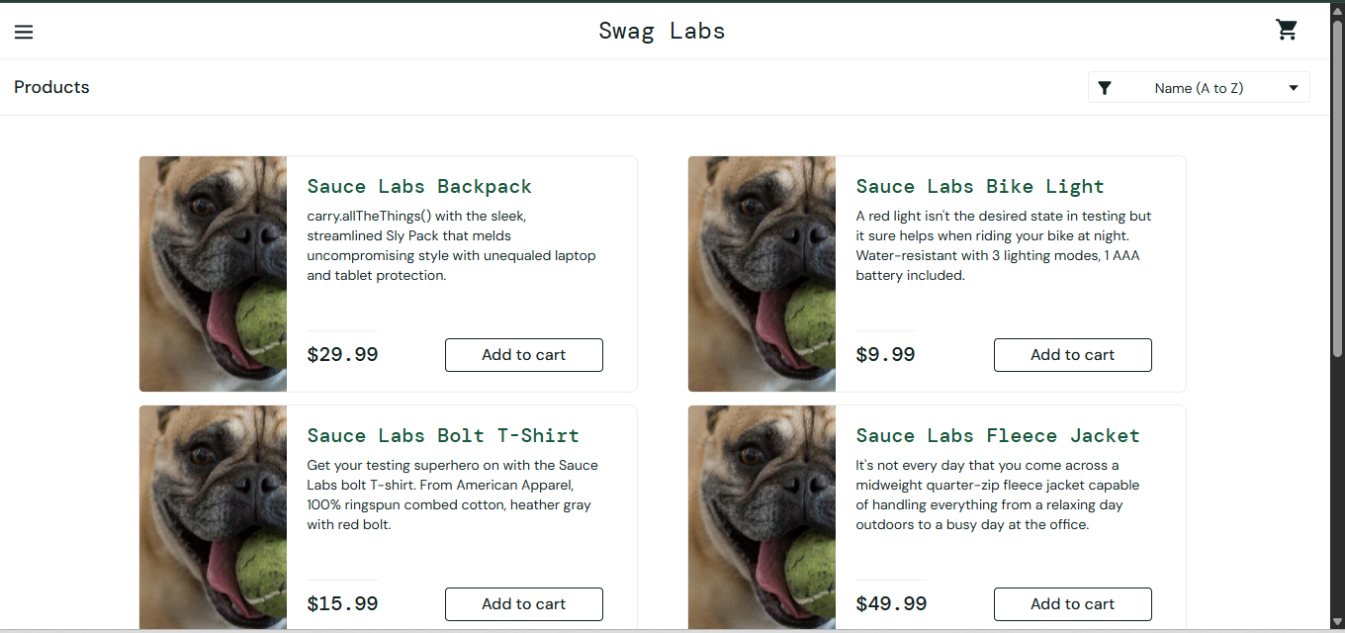
[BUG-03] Checkout Form Accepts Invalid/Malformed Text
Environment | Any modern browser with stable internet connectivity
Severity | High
Priority | High
Status | New / Open
Description:
The first step of the checkout process does not validate user input fields. The form incorrectly accepts completely invalid text—such as random symbols, single letters, spaces, or numbers—in the First Name, Last Name, and Postal Code fields, allowing the user to proceed with the checkout sequence seamlessly.
Steps to Reproduce:
1. Go to https://www.saucedemo.com/ and log in using standard credentials (Username: standard_user, Password: secret_sauce).
2. Add any item to the cart and click the Shopping Cart icon in the top right.
3. Click the Checkout button to go to the information page.
4. Fill out the First Name, Last Name, and Zip/Postal Code fields with invalid data (e.g., symbols like @#$%, single numbers like 7, or just blank spaces).
5. Click the Continue button.
Execution Results:
Expected: The system should block the submission, display an error message, and ask the user to enter a valid name and postal code format.
Actual: The form bypasses validation without any errors and successfully moves the user to the next step of the checkout (/checkout-step-one.html).
Attachment Field / Snapshots:
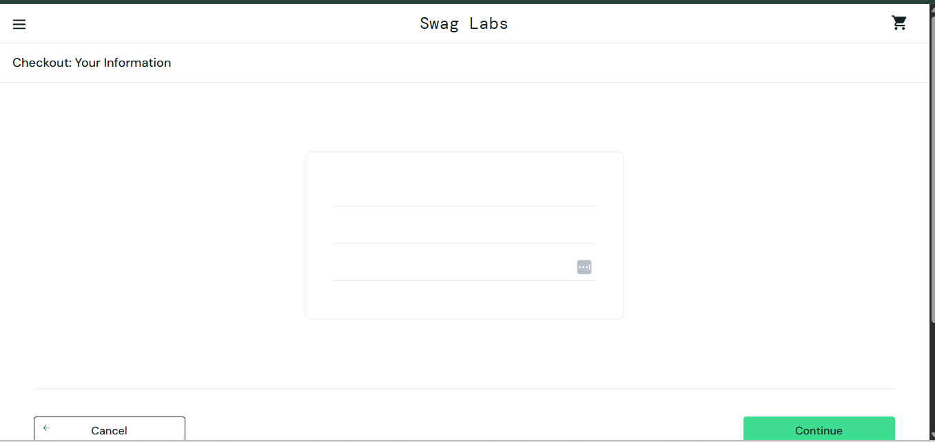
[BUG-04] Checkout Allowed with an Empty Shopping Cart
Environment | Any modern browser with stable internet connectivity
Severity | Critical
Priority | High
Status | New / Open
Description:
The application allows users to proceed to the checkout process even if their shopping cart is completely empty. The 'Checkout' button remains active and clickable, failing to check if any items are actually in the cart container.
Steps to Reproduce:
1. Go to https://www.saucedemo.com/ and log in using standard credentials.
2. Do not add any items to the cart. Click directly on the Shopping Cart icon in the top right corner.
3. On the cart page (/cart.html), observe the 'Checkout' button and click it.
Execution Results:
Expected: Since the cart is empty, the Checkout button should be disabled (grayed out) or clicking it should show an error message like: 'Your shopping cart is empty. Please add at least one item to proceed.'
Actual: The Checkout button is fully active. Clicking it successfully advances the user to the first step of the checkout form (/checkout-step-one.html) with zero items in the order.
Attachment Field / Snapshots:
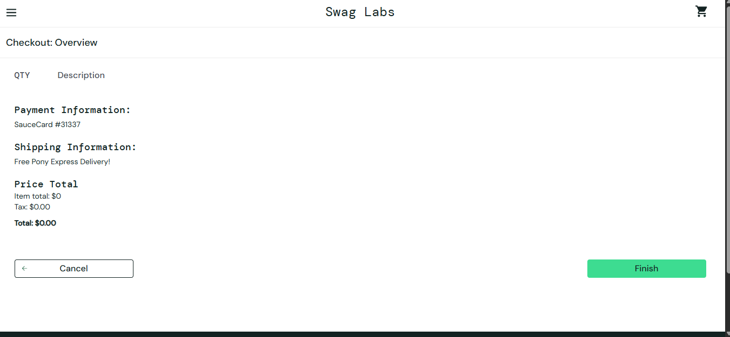
[BUG-05] "Reset App State" Fails to Revert Product Buttons back to "Add to Cart"
Environment | Any modern browser with stable internet connectivity
Severity | Low
Priority | Medium
Status | New / Open
Description:
The 'Reset App State' option in the side menu only partially resets the application. While it successfully clears the item count from the shopping cart icon, it fails to update the individual product cards on the page. The buttons for previously added items remain stuck on 'Remove' instead of reverting back to 'Add to cart'.
Steps to Reproduce:
1. Go to https://www.saucedemo.com/ and log in using standard credentials.
2. Click the Add to cart button on any product.
3. Open the side menu by clicking the menu icon (three lines) in the top-left corner.
4. Click the Reset App State link.
5. Close the side menu and look at the shopping cart icon and the product you just added.
Execution Results:
Expected: The application state should be completely reset. The shopping cart badge should clear to zero, and the product button should instantly change from 'Remove' back to 'Add to cart'.
Actual: The shopping cart badge clears properly, but the product button is stuck showing a red Remove text. The user cannot re-add the item without manually toggling it.
Attachment Field / Snapshots:
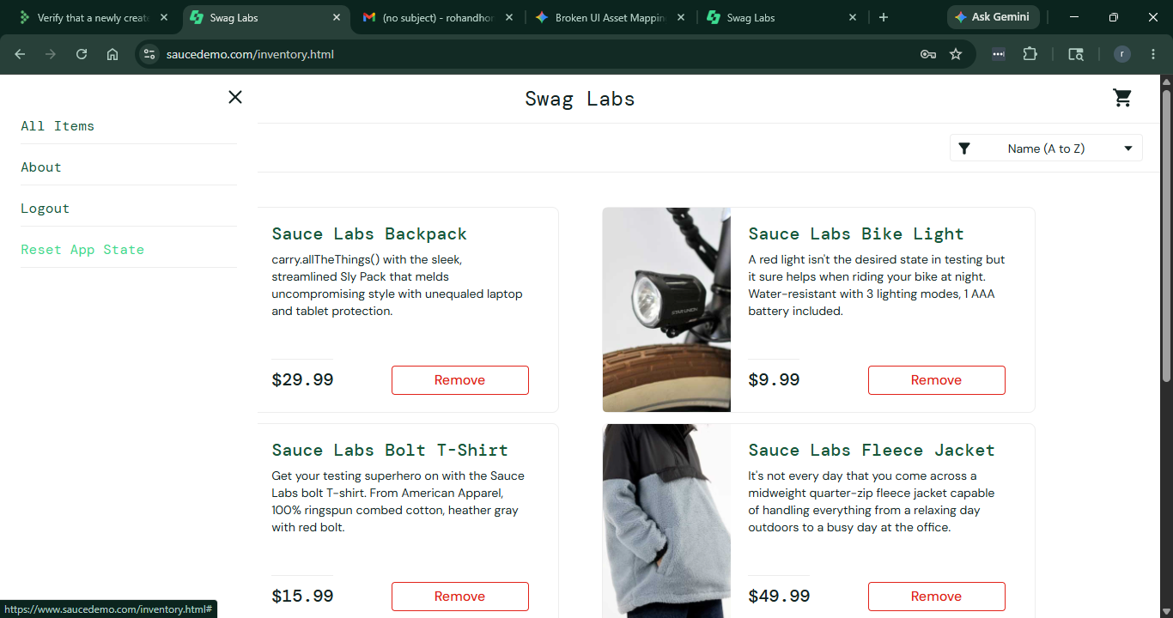
[BUG-06] "Remove" Button Fails to Work for Specific Users
Environment | Any modern browser with stable internet connectivity
Severity | High
Priority | High
Status | New / Open
Description:
For specific user accounts (problem_user, error_user, and visual_user), the Remove button on product cards does not work. After adding an item to the cart, clicking the Remove button does absolutely nothing—the button stays stuck on 'Remove' and the item cannot be deleted from the shopping cart.
Steps to Reproduce:
1. Go to https://www.saucedemo.com/ and log in using one of these usernames: problem_user, error_user, or visual_user with password: secret_sauce.
2. Click the Add to cart button on any product.
3. Verify that the button changes to a red Remove text and the shopping cart count goes up.
4. Click directly on that Remove button.
Execution Results:
Expected: The button should instantly change back to Add to cart, and the item should be removed from the shopping cart (reducing the cart icon count by 1).
Actual: Clicking the button does nothing. It stays stuck showing red Remove text, the item remains in the cart, and the cart count does not decrease, blocking the user from managing choices.
Attachment Field / Snapshots:
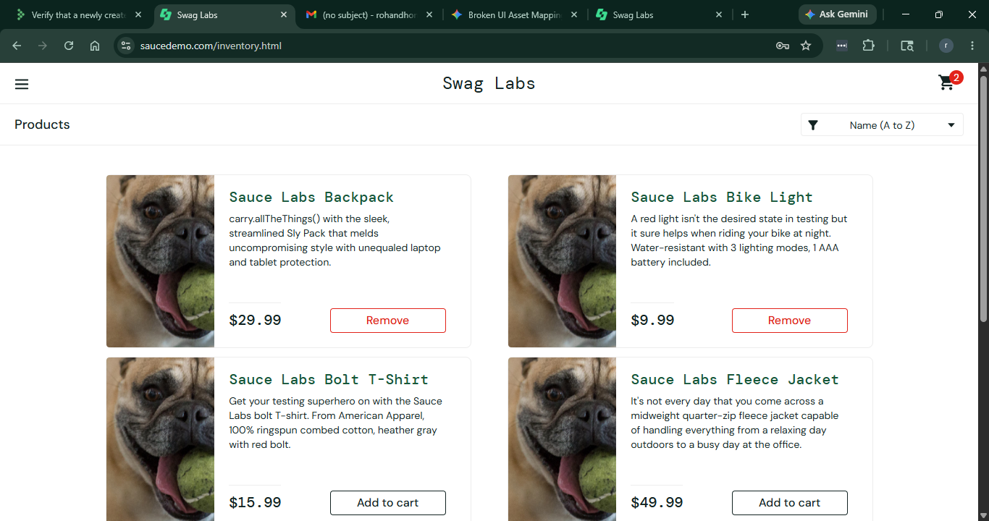
[BUG-07] UI-UX Regression / Layout Misalignment and Broken Component Positioning
Environment | Any modern browser with stable internet connectivity
Severity | Low
Priority | Low
Status | New / Open
Description:
When logging in using the visual_user profile, a global design layout issue occurs. Core interface elements—specifically the shopping cart icon badge and the primary 'Checkout' button—fail to align properly, rendering in distorted, misaligned, or structurally broken page positions.
Steps to Reproduce:
1. Navigate to the application web endpoint URL: 'https://www.saucedemo.com/'
2. Authenticate utilizing the specific targeted user profile identifier 'visual_user' with the password token 'secret_sauce'.
3. Once routed to the workspace product dashboard shelf view, interactively select the 'Add to cart' button component on an inventory card asset.
4. Open the global shopping basket page layout view to evaluate structural button balance.
5. Inspect the precise positioning, margins, and bounding layouts of both the upper-right corner header cart badge element and the transitional 'Checkout' operational action button blocks.
Execution Results:
Expected: The page should follow a clean grid layout. The shopping cart icon should stay neatly in the top-right header, and the Checkout button should be perfectly centered and balanced.
Actual: The design breaks completely. The shopping cart badge shifts out of its regular boundary line, and the Checkout button misaligns, breaking away from standard margins.
Attachment Field / Snapshots:
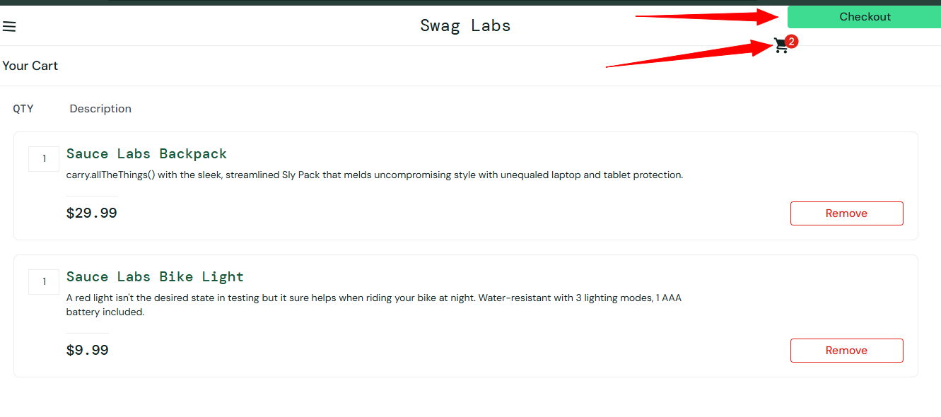
[BUG-08] "Add to Cart" Button Does Not Work on Product Detail Page (problem_user)
Environment | Any modern browser with stable internet connectivity
Severity | High
Priority | High
Status | New / Open
Description:
When using the problem_user account, navigating into a product's individual details page completely breaks that item's checkout process. Once on the separate item details view, the Add to cart button becomes completely non-responsive, preventing users from adding the item to their cart from the detailed layout tier.
Steps to Reproduce:
1. Navigate to the application web endpoint URL: 'https://www.saucedemo.com/'
2. Authenticate using the designated profile identifier 'problem_user' with the password string 'secret_sauce'.
3. From the main page, click directly on the title text link anchor of any product (e.g., 'Sauce Labs Backpack') to open its detailed page.
4. Once the separate details page loads completely, locate and click on the primary interactive 'Add to cart' CTA action button component.
Execution Results:
Expected: The button should process the click normally: the text should change to 'Remove' and the shopping cart icon count in the header should immediately increase by 1.
Actual: The button registers the click but does absolutely nothing. The text stays stuck on 'Add to cart' and the shopping cart badge count remains at 0, entirely blocking details-tier order selections.
Attachment Field / Snapshots:
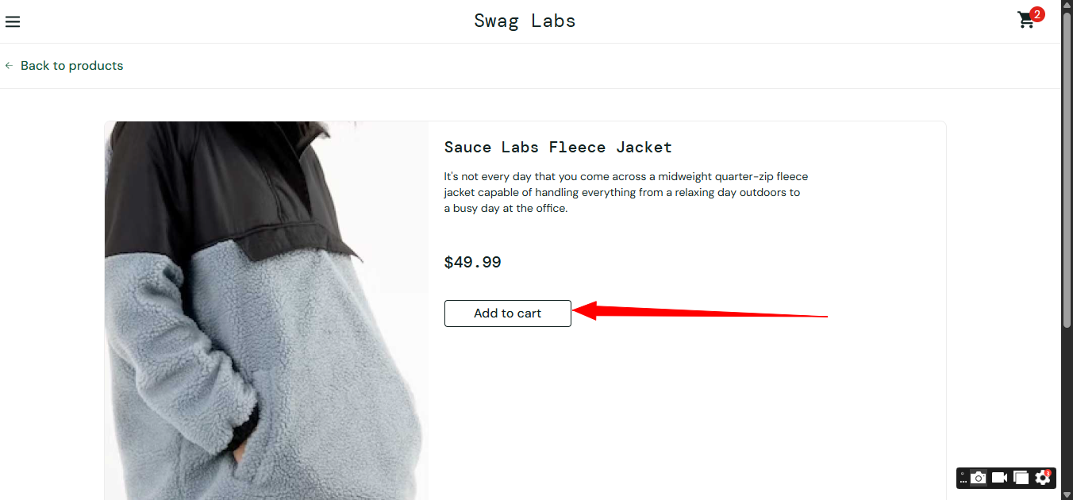
[BUG-09] Sort Filter Option Malfunctions (error_user)
Environment | Any modern browser with stable internet connectivity
Severity | Low
Priority | Medium
Status | New / Open
Description:
When using the error_user account, the core sorting feature on the main product shelf malfunctions. Selecting the filter selection dropdown to sort inventory elements dynamically by financial cost values fails to arrange the product cards, leaving items locked in their original sequence.
Steps to Reproduce:
1. Navigate to the application web endpoint URL: 'https://www.saucedemo.com/'
2. Authenticate using the designated profile identifier 'error_user' with the password token 'secret_sauce'.
3. On the primary inventory dashboard collection shelf, locate the sorting dropdown container element in the upper-right control lane.
4. Select any option.
5. Observe the UI.
Execution Results:
Expected: The product cards should be rearranged dynamically. For example, choosing 'Price (low to high)' must display products in a strict ascending price sequence.
Actual: Alert prompt opens stating that the sorting is broken.
Attachment Field / Snapshots:
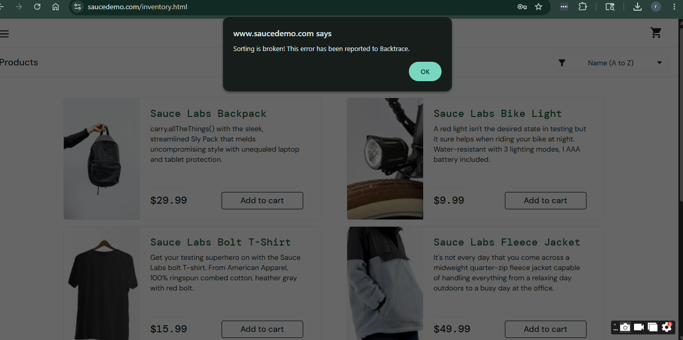
[BUG-10] Alphabetical "Name (A to Z)" Sort Fails to Sort Correctly (problem_user)
Environment | Any modern browser with stable internet connectivity
Severity | Low
Priority | Medium
Status | New / Open
Description:
When active under the problem_user profile, sorting products alphabetically by name is broken. Choosing the 'Name (A to Z)' rule maps incorrect data arrays across product titles, causing items to arrange in a totally disordered sequence, violating normal alphabetical indexing logic.
Steps to Reproduce:
1. Navigate to the application web endpoint URL: 'https://www.saucedemo.com/'
2. Authenticate using the designated profile identifier 'problem_user' with the password token 'secret_sauce'.
3. Locate the interactive sort selection dropdown element container found in the upper-right toolbar layer of the inventory page.
4. Select the alphabetical listing rule option labeled 'Name (A to Z)'.
5. Analyze the vertical layout and evaluate the precise alphabetical title sequence of the generated product cards.
Execution Results:
Expected: The cards should smoothly organize in an exact alphabetical order based on item names (e.g., Backpack -> Bike Light -> Bolt T-Shirt -> Fleece Jacket).
Actual: The filter fails to apply alphabetical algorithms. Product rows load in a broken, random sequence (e.g., Backpack appears directly before Fleece Jacket instead of Bike Light), presenting a broken sorting matrix.
Attachment Field / Snapshots:
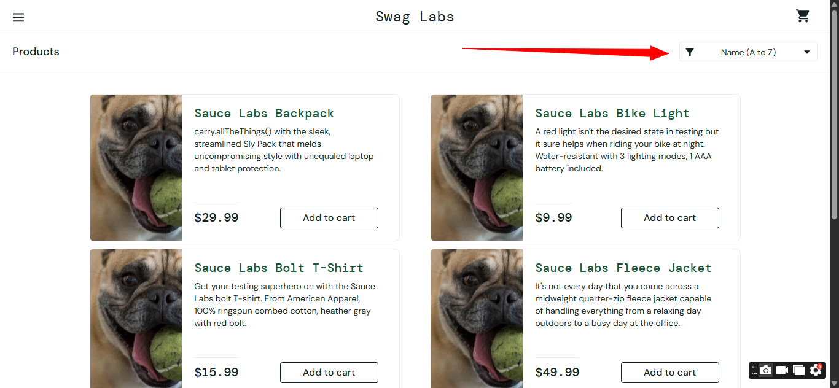
[BUG-11] "Add to Cart" Button Fails to Work on Product Detail Page (error_user)
Environment | Any modern browser with stable internet connectivity
Severity | High
Priority | High
Status | New / Open
Description:
When logged into the application using the error_user account, navigating into an individual product's detail page breaks the purchase flow. On this specific product details view, clicking the Add to cart button does absolutely nothing, preventing the user from adding that item to their cart.

Steps to Reproduce:
- Go to https://www.saucedemo.com/ and log in using:
Username: error_user
Password: secret_sauce
- From the main products page, click on the title link of any product to open its individual details page.
- Once the separate details page loads, click directly on the Add to cart button.
Execution Results:
Expected: The button should process the click normally: the text should toggle to "Remove" and the shopping cart count in the top-right header should increase by 1.
Actual: The button absorbs the click but fails to execute any logic. The text stays stuck on "Add to cart" and the shopping cart count remains unchanged.
Attachment Field / Snapshots:
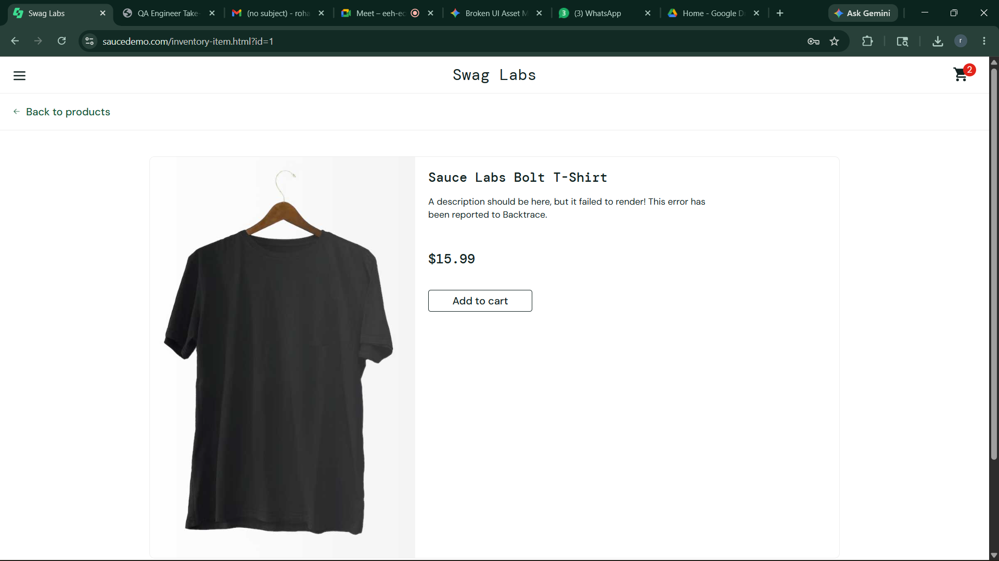

[BUG-12] Checkout Form "Finish" Button Does Not Respond (error_user)
Environment | Any modern browser with stable internet connectivity
Severity | Critical
Priority | High
Status | New / Open
Description:
When logged into the application using the error_user account, a critical deadlock occurs at the final step of the checkout process. After filling out the information forms and reaching the order overview summary page, clicking the green Finish button does absolutely nothing, permanently preventing the user from completing their purchase transaction.
Steps to Reproduce:
- Go to https://www.saucedemo.com/ and log in using:
- Username: error_user
- Password: secret_sauce
- Add any item to the shopping cart and click the Shopping Cart icon in the top right corner.
- Click the Checkout button.
- Fill out the First Name, Last Name, and Zip/Postal Code fields with valid text, and click Continue.
- On the final checkout overview page (/checkout-step-two.html), scroll down and click directly on the green Finish action button.
Execution Results:
Expected: The system should successfully process and submit the final order payload, clearing the cart and routing the user forward to the order completion milestone page (/checkout-complete.html).
Actual: The checkout sequence freezes completely. Clicking the green Finish button results in zero system response, displays no error warnings, and leaves the user permanently stuck on the review page.
Attachment Field / Snapshots:
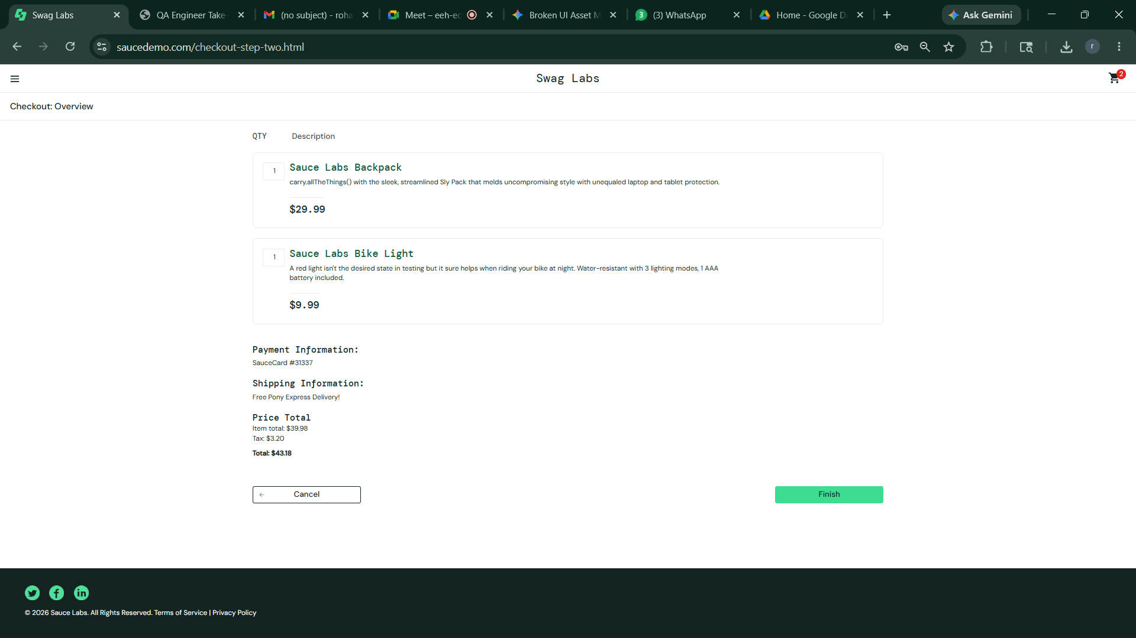
[BUG-13] Clicking Fleece Jacket Title Links to Broken "404 Not Found" Page (problem_user)
Environment | Any modern browser with stable internet connectivity
Severity | Low
Priority | Medium
Status | New / Open
Description:
When logged in using the problem_user account, clicking on the title link text or image anchor for the Sauce Labs Fleece Jacket breaks the application's routing mechanism. Instead of opening the item's details view page, the user session is redirected to a broken internal landing page displaying an "ITEM NOT FOUND" or empty layout error state.

Steps to Reproduce:
- Go to the login page: https://www.saucedemo.com/
- Log in using the designated credentials:
Username: problem_user
- Password: secret_sauce
- Locate the Sauce Labs Fleece Jacket item block card on the main product dashboard inventory path (/inventory.html).
- Click directly on either the product's title text link ("Sauce Labs Fleece Jacket") or its thumbnail graphic image container.
Execution Results:
Expected: The application should cleanly handle the navigation query, successfully parsing the product index metadata and loading the standalone details page configuration (/inventory-item.html?id=4) featuring individual pricing and functional item action controls.
Actual: The browser redirects to a broken structural viewpoint displaying an explicit layout breakdown indicating that the requested product item could not be resolved or found.
Attachment Field / Snapshots:
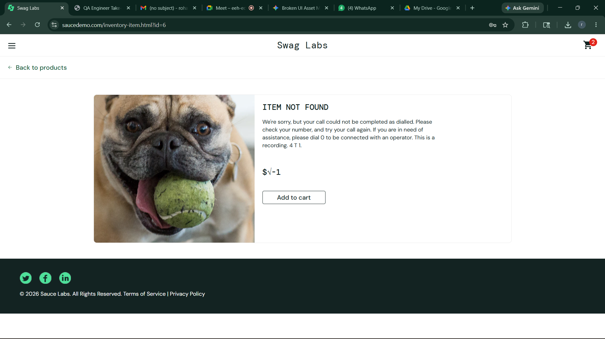
[BUG-14] Clicking "About" Link leads to Broken "404 Not Found" Error (problem_user)
Environment | Any modern browser with stable internet connectivity
Severity | Low
Priority | Low
Status | New / Open
Description:
When logged into the application using the problem_user account, interacting with the side navigation sidebar menu causes a routing exception. Specifically, clicking on the About menu item incorrectly redirects the user to a standard external or internal "404 Not Found" error landing page instead of loading the company information landing view.
Steps to Reproduce:
- Go to the application login landing page: https://www.saucedemo.com/
- Log in using the designated testing credentials:
- Username: problem_user
- Password: secret_sauce
- Click on the sidebar drawer menu hamburger icon (three lines) in the upper-left area of the header layer to expand the global navigation panels.
- Click directly on the About sidebar link component item.
Execution Results:
Expected: Authentication processing and endpoint routing should execute smoothly, loading the main page (/inventory.html) within a standard performance threshold (e.g., under 1 second).
Actual: The application encounters a severe performance glitch, causing a noticeable delay of several seconds where the UI remains completely frozen before finally resolving the landing page layout.
Attachment Field / Snapshots:
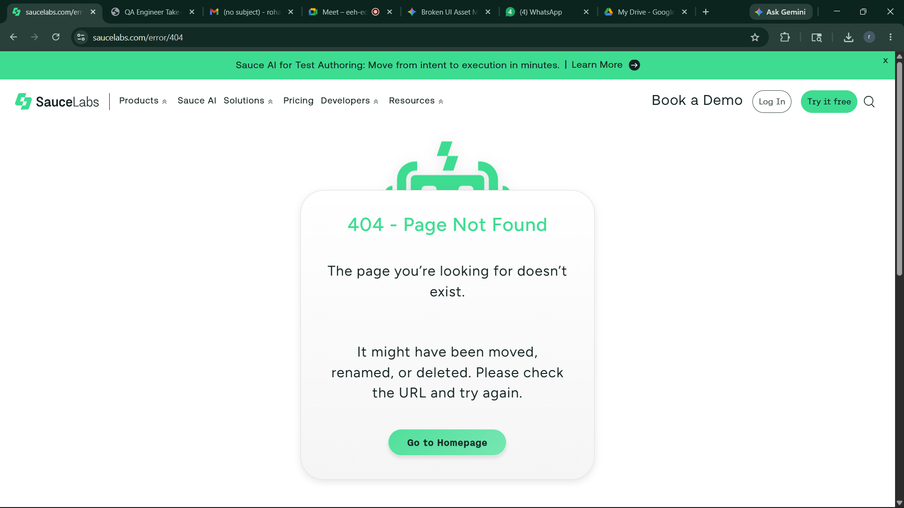
[BUG-15] Critical Loading Delay During Login (performance_glitch_user)
Environment | Any modern browser with stable internet connectivity
Severity | Medium
Priority | Medium
Status | New / Open
Description:
When attempting to authenticate using the performance_glitch_user account profile, the application experiences a severe performance bottleneck. Triggering the form submission causes the system to hang on a loading state for an unacceptable amount of time before finally granting access and routing the user to the inventory page.
Steps to Reproduce:
- Go to the login page: https://www.saucedemo.com/
- Enter the Username: performance_glitch_user
- Enter the Password: secret_sauce
- Click the Login button.
- Observe the latency and loading delay before the workspace dashboard completely renders.
Execution Results:
Expected: Authentication processing and endpoint routing should be executed smoothly, loading the main page (/inventory.html) within a standard performance threshold (e.g., under 1 second).
Actual: The application encounters a severe performance glitch, causing a noticeable delay of several seconds where the UI remains completely frozen before finally resolving the landing page layout.
Attachment Field / Snapshots:
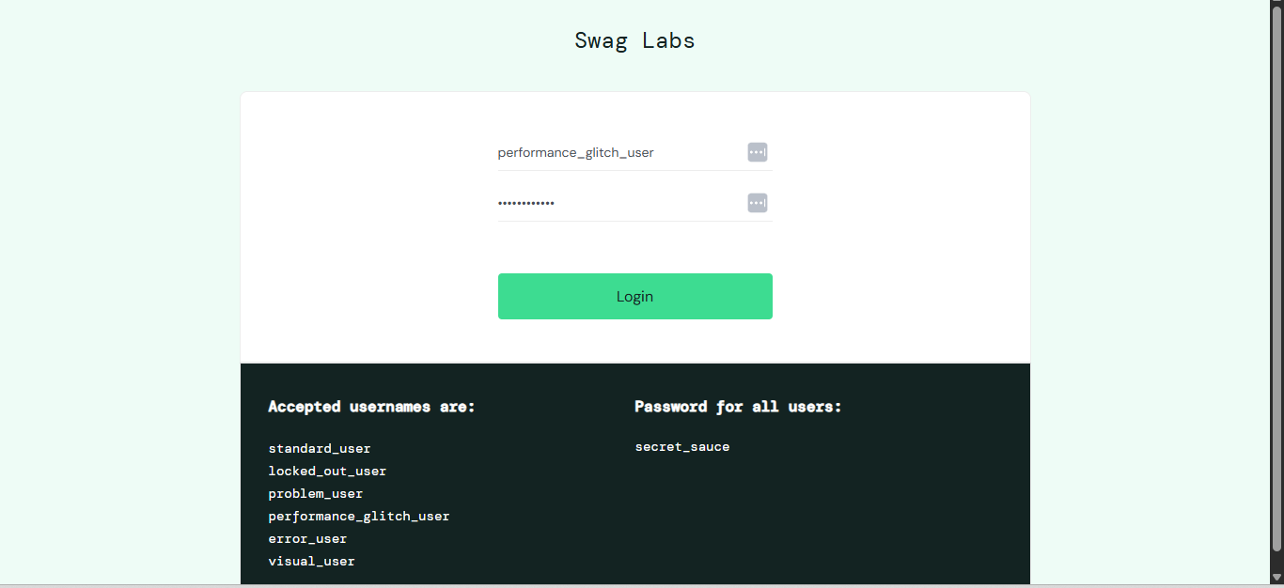
[BUG-16] Checkout Form "Last Name" Field Blocks Keyboard Input (error_user)
Environment | Any modern browser with stable internet connectivity
Severity | High
Priority | High
Status | New / Open
Description:
When a user is logged in under the error_user account profile, the first step of the checkout process suffers from an input defect. The Last Name form text field is completely locked or non-responsive, preventing the user from typing any characters into it via keyboard input.
Steps to Reproduce:
- Go to the application web endpoint URL: https://www.saucedemo.com/
- Authenticate using the designated profile identifier:
- Username: error_user
- Password: secret_sauce
- Add any product item to the shopping cart container and click on the global Shopping Cart icon in the upper right header lane.
- Click the primary operational Checkout button to navigate to the information page (/checkout-step-one.html).
- Click inside the Last Name input box container and attempt to type text strings.
Execution Results:
Expected: The input field component should capture focus, respond to keyboard events gracefully, and display the typed string parameters dynamically.
Actual: The field completely ignores keystroke events. The cursor remains frozen, blocking the user from populating their last name data and halting the entire transactional process.
Attachment Field / Snapshots:
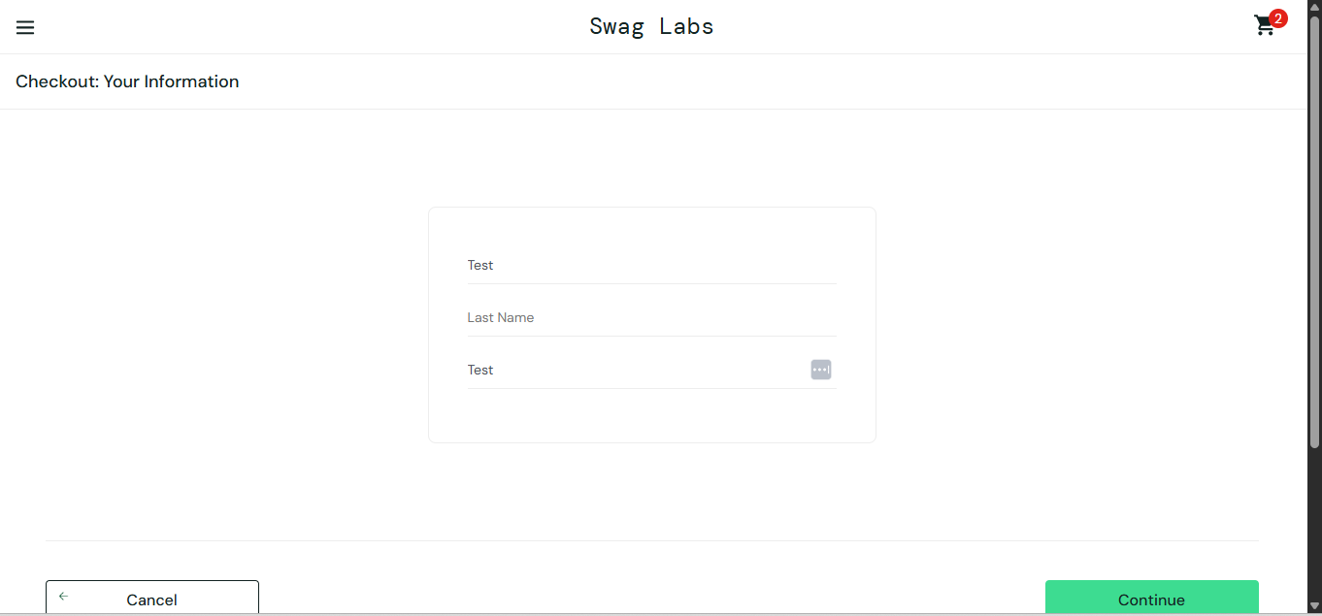
[BUG-17] "Add to Cart" Buttons Broken for Specific Inventory Items (problem_user)
Environment | Any modern browser with stable internet connectivity
Severity | High
Priority | High
Status | New / Open
Description:
The product catalog shelf experiences a selective functional breakdown. While some inventory items can be successfully added to the shopping basket, specific products—including the Sauce Labs Bolt T-Shirt, Sauce Labs Fleece Jacket, and Sauce Labs Onesie—have completely non-responsive action buttons that fail to update the application state when clicked.
Steps to Reproduce:
- Go to the application web endpoint URL: https://www.saucedemo.com/
- Authenticate using standard test credentials (Username: standard_user, Password: secret_sauce) or the affected profile context.
- On the main products inventory grid page (/inventory.html), click the Add to cart button on a working item (e.g., Sauce Labs Backpack) to verify general cart functionality.
- Locate the Sauce Labs Bolt T-Shirt, Sauce Labs Fleece Jacket, or Sauce Labs Onesie.
- Click directly on the Add to cart action button component for any of these specific items.
Execution Results:
Expected: The element should handle the click event successfully: the button text/style should instantly toggle to display a red "Remove" configuration, and the global shopping cart icon badge in the upper right header lane should increment its counter value by 1.
Actual: The button absorbs the click event but triggers no business logic. The component text remains locked on "Add to cart", its visual state fails to change, and the global shopping cart badge counter remains unchanged, blocking order selections for these specific products.
Attachment Field / Snapshots:
